**Birla Institute of Technology & Science, Pilani**

**Work-Integrated Learning Programmes Division**

**First Semester 2022-2023**

**Comprehensive Examination (EC-3 Make-up)**

Course No. : SE ZG685

Course Title : SOFTWARE PRODUCT MANAGEMENT

Nature of Exam : Open Book

Weightage : 40%

No. of Pages = 3

No. of Questions = 8

Duration : 2 Hours

Date of Exam : Saturday, 26/11/2022 (FN)

Note:

1. Please follow all the *Instructions to Candidates* given on the cover page of the answer book.
2. All parts of a question should be answered consecutively. Each answer should start from a fresh page.
3. Assumptions made if any, should be stated clearly at the beginning of your answer.
   1. Design 4 Customer interview Questions to assess the value of the product described in the case study “FastTag”. [4]

Ans:

How is compare to other product

Chatgpt ans

How has the FastTag product improved your experience with toll payments? Can you provide specific examples of how it has made the process more convenient or efficient for you?

This question helps to gauge the overall impact of FastTag on the customer's experience with toll payments. It encourages the customer to provide specific instances where the product has brought value by streamlining the payment process.

Prior to using FastTag, what challenges or frustrations did you encounter with traditional toll payment methods? How has FastTag addressed or resolved these challenges for you?

This question aims to uncover the pain points and difficulties customers faced before adopting FastTag. It allows them to compare their previous experiences with the benefits and solutions provided by FastTag, highlighting the value the product brings in addressing those challenges.

Have you noticed any cost savings or time savings since using FastTag? Can you estimate the impact it has had on your expenses or travel time?

This question explores the financial and time-related benefits customers have experienced with FastTag. It helps assess the value in terms of tangible outcomes, such as reduced costs or saved time, which are essential factors for customers in evaluating a product's worth.

How does FastTag compare to other toll payment options you have used or considered? What unique features or advantages does FastTag offer in comparison?

This question seeks to understand how FastTag differentiates itself from other competing solutions in the market. By comparing FastTag to alternative options, customers can express their perceptions of the product's unique features, advantages, or value propositions that set it apart from the competition.

* 1. Design 4 Customer interview Questions to assess the value of the software product described in the case study “DBS home loan”. [4]
  2. Design 4 Customer interview Questions to assess the value of the software product described in the case study “Acko car insurance”. [4]

* 1. Analyze product market fit of “Toothsi dental aligner app”. Create the lean canvas board. [4 + 4 = 8]

Ans:

Markte fit of Toothsi dental aligner app

* Target customer – (Market)
* Under serve needs – (Market)
* Value proposition – (Product)
* Feature set – (Product)
* UX– (Product)

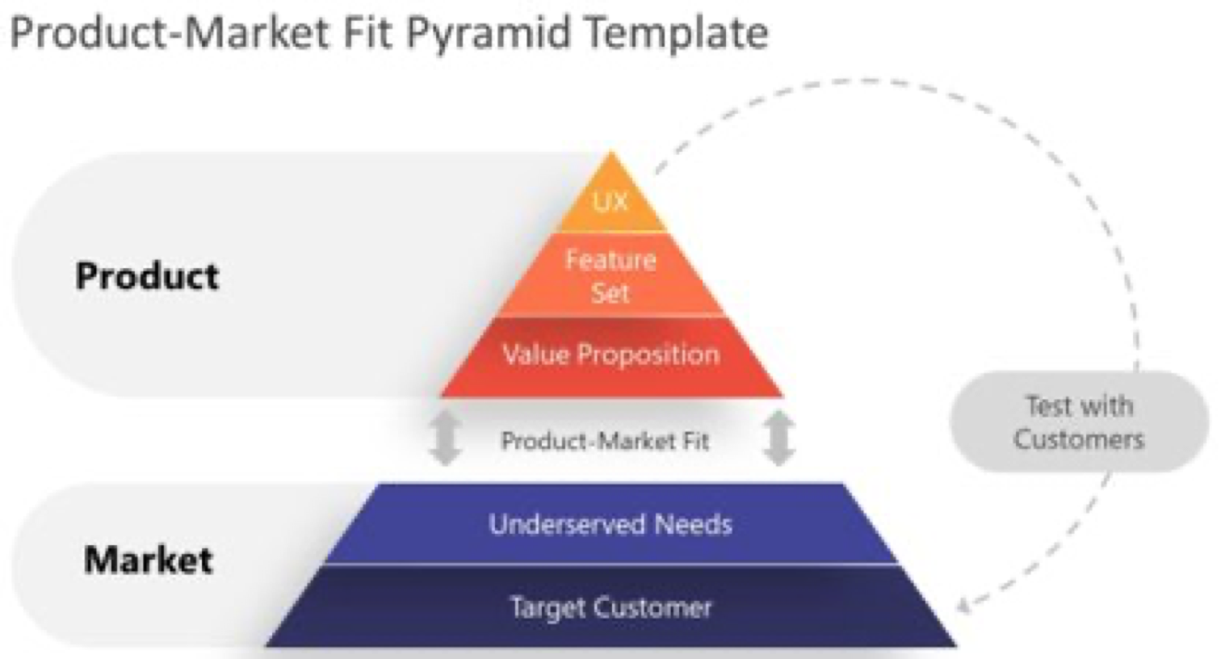

Similar like this



Chatgpt

To analyze the product-market fit of the "Toothsi dental aligner app," let's assess several key aspects:

1. Target Market:

* The app primarily targets individuals with mild to moderate teeth misalignment issues who are seeking a convenient and affordable alternative to traditional orthodontic treatments like braces.
* The target market may consist of tech-savvy individuals who prefer digital solutions and value the flexibility and discretion provided by the app.

1. Problem/Solution Fit:

* The app addresses the problem of teeth misalignment by offering clear aligners as a solution.
* It aims to provide a more convenient and cost-effective option compared to traditional orthodontic treatments, allowing users to improve their smile aesthetics and oral health.

1. Value Proposition:

* Convenient and accessible treatment: The app offers the convenience of remote treatment planning and monitoring, eliminating the need for frequent in-person visits to the orthodontist.
* Affordability: The app positions itself as a more affordable option compared to traditional braces, making teeth alignment accessible to a wider audience.
* Professional care: The app provides access to qualified orthodontists who remotely monitor the progress and provide guidance throughout the treatment process.

1. Customer Acquisition:

* The app can leverage digital marketing channels, social media platforms, and online communities to reach and engage with its target audience.
* Partnerships with dental clinics or influencers in the oral health and beauty space could help drive customer acquisition through referrals and endorsements.

1. Customer Retention:

* Customer satisfaction is crucial for retaining app users. Positive treatment outcomes, effective communication with orthodontists, and a user-friendly experience are vital for keeping customers engaged and satisfied.
* Regular check-ins, progress tracking, and support mechanisms within the app can help maintain customer retention.

1. Competitive Landscape:

* The dental alignment market may have competition from other clear aligner providers, traditional orthodontic treatments, or other digital solutions.
* The app's value proposition, affordability, professional care, and convenience should be emphasized to differentiate itself from competitors.

1. Scalability and Growth Potential:

* As more individuals seek convenient and affordable teeth alignment options, there is potential for growth and scalability in the market.
* Expanding the app's reach to new regions, introducing additional dental services or treatments, and continuously improving the user experience can contribute to long-term growth.

To assess the product-market fit of the "Toothsi dental aligner app," it is crucial to gather feedback from users, track customer satisfaction, and evaluate the app's adoption and retention rates. This data will provide insights into the app's effectiveness in addressing customer needs and its alignment with the target market. Adjustments and improvements can then be made to enhance the product-market fit and ensure long-term success

* 1. Analyze product market fit of “Redbus bus booking app”. Create the lean canvas board. [4 + 4 = 8]
  2. Analyze product market fit of “RazorPay payment gateway app”. Create the lean canvas board. [4 + 4 = 8]

Q.3Set(A) Discuss Positioning and Messaging for Twilio product. [4]

Ans:

Positioning: Twilio's positioning should emphasize its key differentiators and unique selling points (USPs). Here are some potential positioning statements for Twilio:

* Twilio is the cloud communication platform that enables developers and businesses to quickly and easily build and scale real-time communication applications across multiple channels.
* Twilio provides powerful APIs and flexible SDKs that enable businesses to integrate messaging, voice, and video communication capabilities into their applications with ease.
* Twilio empowers businesses of all sizes to create meaningful customer experiences by enabling real-time communication on any channel, at any scale.

Messaging: To support its positioning, Twilio's messaging should focus on the benefits and outcomes that customers can achieve by using the platform. Here are some potential messaging themes for Twilio:

* Empowering businesses to create engaging customer experiences through real-time communication
* Enabling developers to build and scale communication applications quickly and easily
* Providing a reliable, secure, and flexible communication platform that can integrate with any application
* Offering a comprehensive suite of communication APIs and tools to meet the needs of businesses across industries

Q.3Set(B) Discuss Positioning and Messaging for Tally product. [4]

Q.3Set(C) Discuss Positioning and Messaging for AirBnB product. [4]

1. “Prove your product first, scale / optimize later” is a best practice for startups. How was this done in case of ID Fresh foods? [4]

Ans:

1. Quality focus: ID Fresh Foods prioritized the quality of their products from the very beginning. They ensured that their food items were made with fresh ingredients, hygienically processed, and free from preservatives. This commitment to quality helped them gain customer trust and loyalty.
2. Localized operations: Instead of trying to reach a wide audience from the start, ID Fresh Foods initially focused on serving the local market. They started with a single city (Bengaluru) and expanded gradually to other cities, ensuring that they were able to maintain product quality, customer satisfaction, and operational efficiency.
3. Word-of-mouth marketing: ID Fresh Foods relied heavily on word-of-mouth marketing to generate awareness and build a customer base. By consistently delivering high-quality products, they earned positive reviews and recommendations from customers, which helped them gain traction and establish a strong reputation.
4. Continuous improvement: While scaling their operations, ID Fresh Foods continued to invest in research and development to improve their products and processes. They actively sought customer feedback, incorporated suggestions, and fine-tuned their recipes and production methods. This dedication to continuous improvement allowed them to maintain product quality while scaling their operations.
5. Scalability and optimization: Once ID Fresh Foods had established a strong foundation and proven their product in the market, they focused on scaling up and optimizing their operations. They implemented advanced technology, automated processes, and expanded their production facilities to meet growing demand without compromising on quality.
6. “Prove your product first, scale / optimize later” is a best practice for startups. How was this done in case of Spotify? [4]

Ans:

1. “Prove your product first, scale / optimize later” is a best practice for startups. How was this done in case of Netflix? [4]
2. Which funding sources are suited for new startups. Justify [4]

Ans:

* Angel

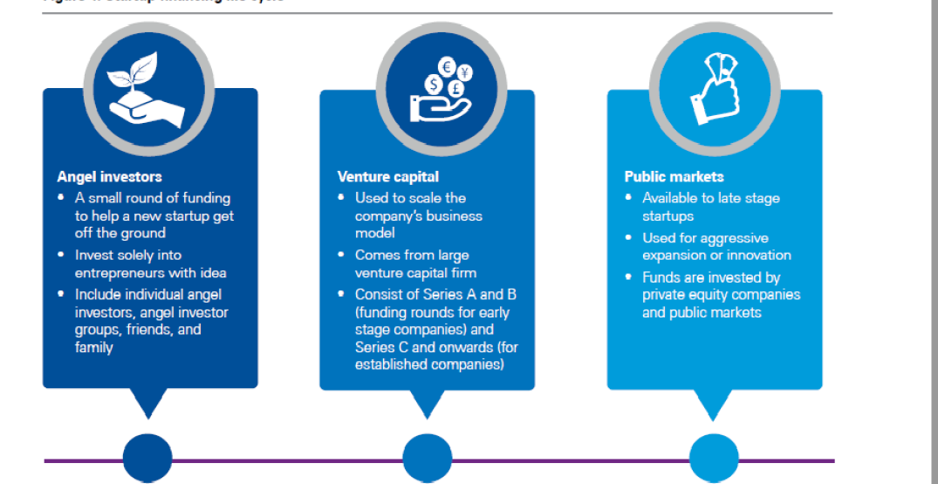

1. Which funding sources are suited for established and stable company. Justify [4]

Ans:

* Venture capital

1. Which funding sources are suited for socially responsible company. Justify [4]

Ans:

* Crowd funding

1. Which revenue model would you recommend for ‘Google Drive’ for corporates? Justify. [4]

Ans:

Subscription

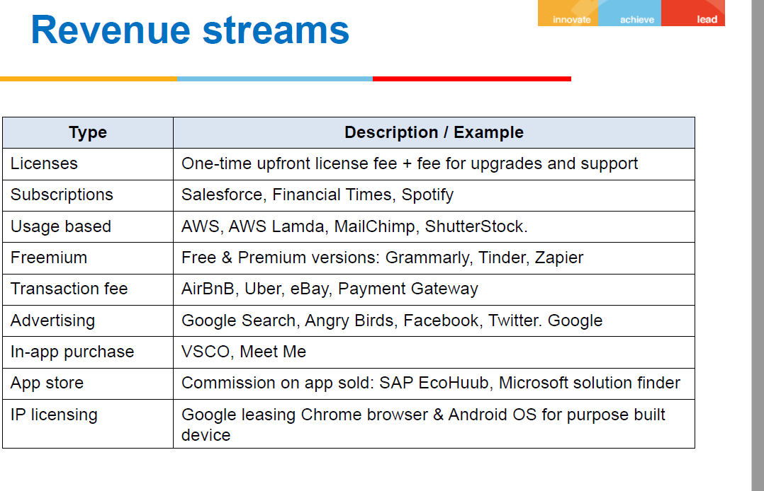

1. Which revenue model would you recommend for ‘Postman API testing’ product? Justify. [4]

Ans:

subscription-based revenue

1. Which revenue model would you recommend for ‘Kissflow” for corporates? Justify. [4]
2. 2 friends got together to launch as B2B product company. In the first year they assessed the product idea, built an MVP to validate the idea, put together a team to build the product.

In the second year they started selling the product to a few companies and in the third year they increased their sales to even more customers.

In the first year the company did not make any profit. In the second year they made a small profit and in the third year they made even more profit. At the end of the third year their reached the break-even point.

Based on the description given above, explain how the company claims to have made profit in year 2 while the break-even was reached only at end of year 3. [4]

Ans:

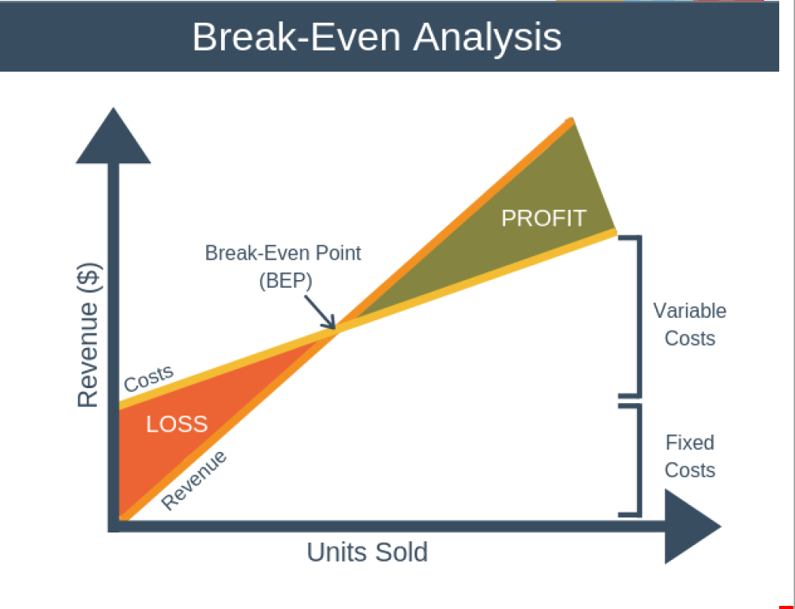

1. 2 friends got together to launch as B2B product company. In the first year they assessed the product idea, built an MVP to validate the idea, put together a team to build the product.

In the second year they started selling the product to a few companies and in the third year they increased their sales to even more customers.

In the first year the company did not make any profit. In the second year they made a small profit and in the third year they made even more profit. At the end of the third year their reached the break-even point.

Based on the description given above, explain how the company claims to have made profit in year 2 while the break-even was reached only at end of year 3. [4]

1. 2 friends got together to launch as B2B product company. In the first year they assessed the product idea, built an MVP to validate the idea, put together a team to build the product.

In the second year they started selling the product to a few companies and in the third year they increased their sales to even more customers.

In the first year the company did not make any profit. In the second year they made a small profit and in the third year they made even more profit. At the end of the third year their reached the break-even point.

Based on the description given above, explain how the company claims to have made profit in year 2 while the break-even was reached only at end of year 3. [4]



* Using the concept described in the book “Innovator’s Dilemma”, explain why large companies like SAP did not embrace cloud technology early, compared to startups such as SalesForce.com. [4]

Ans:

Example like Nokia, Kodak

* Using the “3-box solution” described by Prof. Vijay Govindarajan, explain how Adobe moved its product (s) from desktop to cloud. [4]

Ans:

The "3-box solution" framework, proposed by Prof. Vijay Govindarajan, involves managing three boxes simultaneously to drive innovation and transformation within an organization. Let's apply this framework to understand how Adobe moved its products from the desktop to the cloud:

1. Box 1: Manage the Present In this box, Adobe focused on managing its existing desktop software products, such as Adobe Photoshop, Illustrator, and InDesign. These products were the foundation of Adobe's success, with a large customer base and established market presence. Adobe continued to enhance and optimize these products to meet customer needs while generating revenue.
2. Box 2: Selectively Forget the Past In Box 2, Adobe recognized the need to selectively forget the past and shift its mindset towards the future of cloud-based software. They acknowledged that the future of technology and customer preferences were evolving towards cloud-based solutions. Adobe made a strategic decision to embrace this change and started developing a new cloud-based platform called Adobe Creative Cloud.

Adobe Creative Cloud introduced a subscription-based model that allowed users to access a suite of Adobe software and services through the cloud. By moving away from perpetual licenses and embracing a subscription model, Adobe aimed to provide greater flexibility, seamless updates, and enhanced collaboration capabilities to its customers.

1. Box 3: Create the Future In Box 3, Adobe focused on creating the future by actively building and refining its cloud-based offerings. They invested in developing new features, improving user experiences, and expanding the capabilities of Adobe Creative Cloud. This included features like cloud storage, collaborative workflows, real-time syncing, and mobile integration to cater to the changing needs of creative professionals.

Adobe also adopted a "mobile-first" approach, recognizing the growing importance of mobile devices in the creative process. They introduced mobile apps that seamlessly integrated with Adobe Creative Cloud, enabling users to access and work on their projects across multiple devices.

Over time, Adobe successfully transitioned its product offerings from traditional desktop software to a cloud-based subscription model. By managing the present, selectively forgetting the past, and creating the future, Adobe was able to transform its business and align with the changing market dynamics, providing a more connected and flexible experience for its customers.

The "3-box solution" framework helped Adobe balance its focus on existing revenue-generating products while strategically investing in new cloud-based offerings, allowing them to evolve and stay ahead in a rapidly changing industry.



* Using the concept described in the book “Innovator’s Dilemma”, explain why large companies like SAP did not embrace cloud technology early, compared to startups such as SalesForce.com. [4]
* Using the “3-box solution” described by Prof. Vijay Govindarajan, explain how Adobe moved its product (s) from desktop to cloud. [4]



* Using the concept described in the book “Innovator’s Dilemma”, explain why large companies like SAP did not embrace cloud technology early, compared to startups such as SalesForce.com. [4]
* Using the “3-box solution” described by Prof. Vijay Govindarajan, explain how Adobe moved its product (s) from desktop to cloud. [4]

*******